**Low Level Design (LLD) of CRM**

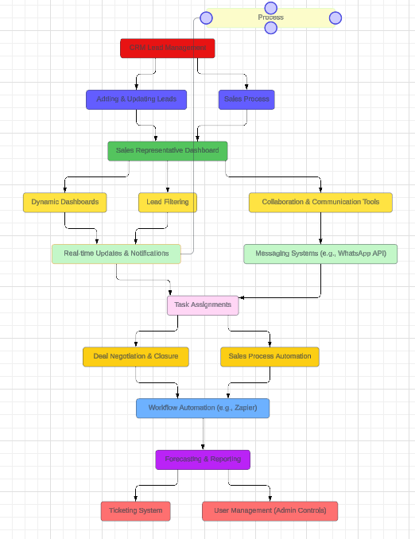

**Lead Management:**

**1. Adding and Updating Leads:**

• Develop user-friendly interfaces for lead entry and updates.

• Create customizable forms to capture lead details effectively.

• Implement validation rules to ensure data accuracy.

• Utilize a centralized database for storing lead information securely.

• Define database structures for efficient data storage.

• Implement data encryption for sensitive lead details.

• Optimize database indexing for quick retrieval of lead records.

• Integrate with external sources for automated lead capture.

**Adding and Updating Leads:**

* Develop user-friendly interfaces for lead entry and updates: Design intuitive forms with clear labels and instructions to make the lead entry and updating process seamless for users.
* Create customizable forms to capture lead details effectively: Allow users to tailor lead capture forms to their specific needs, ensuring all relevant information is collected efficiently.
* Implement validation rules to ensure data accuracy: Set up validation checks to verify the correctness and completeness of lead data, reducing errors and maintaining data integrity.
* Utilize a centralized database for storing lead information securely: Employ a robust database system to store lead data securely, ensuring confidentiality and accessibility as needed.
* Define database structures for efficient data storage: Design database tables and relationships optimized for storing and retrieving lead information efficiently, considering factors like scalability and performance.
* Implement data encryption for sensitive lead details: Apply encryption techniques to safeguard sensitive lead information, such as personal or financial data, from unauthorized access or breaches.
* Optimize database indexing for quick retrieval of lead records: Fine-tune database indexing to speed up search and retrieval operations, enhancing the responsiveness of the CRM system.
* Integrate with external sources for automated lead capture: Establish integrations with external platforms or services to automatically capture leads from sources like website forms, emails, or social media, streamlining the lead acquisition process.

**2. Sales Representative Dashboard:**

• Design dynamic dashboards for sales representatives.

• Provide visual representations of leads in different stages of the sales funnel.

• Implement lead filtering and sorting options for efficient lead management.

• Enable real-time lead updates and notifications.

• Incorporate collaboration and communication tools for team interaction.

• Integrate messaging systems for quick communication (WhatsApp API).

• Enable task assignments directly from the dashboard.

**Sales Process:**

**1. Deal Negotiation and Closure:**

• Develop tools for effective negotiation with leads.

• Enable document sharing within the CRM for proposals and contracts.

• Implement version control for document management.

• Facilitate real-time communication between sales representatives and leads.

• Design a notification system for instant updates on negotiations.

• Streamline pricing and discount management.

• Establish workflows for discount approval and deal approval involving stakeholders.

**2. Opportunity Tracking:**

• Enable creation and management of opportunities.

• Automate opportunity generation upon deal closure.

• Implement forecasting and reporting functionalities.

• Log and track all activities related to each opportunity.

• Automate follow-up tasks and reminders for timely actions.

**Sales Representative Dashboard:**

* Design dynamic dashboards for sales representatives: Create visually appealing and interactive dashboards that provide at-a-glance insights into lead status, performance metrics, and key sales activities.
* Provide visual representations of leads in different stages of the sales funnel: Use charts, graphs, and color-coded indicators to visually represent lead progression through various stages of the sales pipeline, aiding in prioritization and decision-making.
* Implement lead filtering and sorting options for efficient lead management: Enable sales representatives to filter and sort leads based on criteria such as lead source, status, or priority, allowing them to focus on high-potential opportunities.
* Enable real-time lead updates and notifications: Implement real-time updates and notifications to keep sales representatives informed about changes in lead status, interactions, or important events, ensuring timely follow-ups and actions.
* Incorporate collaboration and communication tools for team interaction: Integrate collaboration features such as chat, comments, or shared notes directly into the dashboard to facilitate teamwork and information sharing among sales team members.
* Integrate messaging systems for quick communication (WhatsApp API): Enable seamless communication between sales representatives and leads by integrating messaging platforms like WhatsApp, allowing for quick inquiries, updates, or follow-ups.
* Enable task assignments directly from the dashboard: Empower sales representatives to assign tasks or follow-up actions to themselves or their team members directly from the dashboard, improving task management and accountability.

**User Management:**

**1. Admin Controls:**

• Develop tools for role assignment and permission adjustments.

• Implement granular permissions for different user roles.

• Facilitate user onboarding processes.

• Customize role-based dashboards for user-specific information.

**Customer Support:**

**1. Ticketing System:**

• Create ticketing forms with customizable fields.

• Allow attachment support for additional context.

• Integrate the ticketing system with the CRM for unified customer interaction.

• Associate tickets with customer profiles for a holistic view.

• Log and track all customer support activities within the CRM.

**Marketing Automation:**

1. **Zapier Integration:**

• Integrate with Zapier for workflow automation.

• Create triggers and actions to automate processes within the CRM.

• Automate social media engagement based on CRM data.

• Enable automated follow-ups and email automation.

This LLD outlines the detailed functionalities and features of a CRM system in marketing without specifying the technologies used for implementation. It focuses on the specific workflows and processes necessary for effective customer relationship management and marketing automation.